**Pizza Sale SQL queries**

**A KPI’s**

1. **Total Revenue:**

select sum(total_price) as Total_Revenue

from pizza_sales;

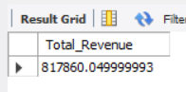

1. **Average Order Value**

select sum(total_price) / count(distinct order_id) as Avg_Order_Value

from pizza_sales;

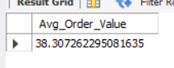

1. **Total Pizzas Sold**

select sum(quantity) as Total_Pizza_Sold

from pizza_sales;

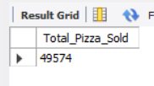

1. **Total Orders**

select count(distinct order_id) as Total_Orders

from pizza_sales;

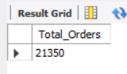

1. **Average pizzas per order**

select cast( sum(quantity) / count(distinct order_id) as decimal(10,2)) as Average_Pizzas_Per_Order

from pizza_sales;

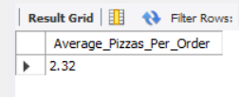

1. **Daily Trend for total orders**

SELECT DAYNAME(STR_TO_DATE(order_date, '%d-%m-%Y')) AS Weekday, count(distinct order_id) as total_order

FROM pizza_sales

group by DAYNAME(STR_TO_DATE(order_date, '%d-%m-%Y'));

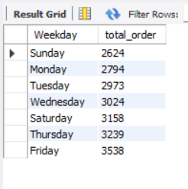

1. **Monthly trend for total orders**

SELECT monthname(STR_TO_DATE(order_date, '%d-%m-%Y')) AS month_name, count(distinct order_id) as total_order

FROM pizza_sales

group by monthname(STR_TO_DATE(order_date, '%d-%m-%Y'));

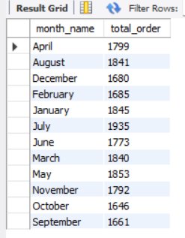

1. **Percentage of sales by pizza category**

select pizza_category, sum(total_price) as total_sale, sum(total_price) * 100 / (select sum(total_price) from pizza_sales) as Percentage_total_sales

from pizza_sales

group by pizza_category;

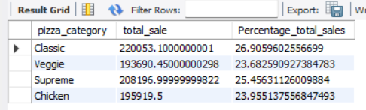

1. **Percentage of sales by pizza category on first month January = 1**

select pizza_category, sum(total_price) as total_sale, sum(total_price) * 100 /

**(select sum(total_price) from pizza_sales**

**where month(STR_TO_DATE(order_date, '%d-%m-%Y')) = 1)** as Percentage_total_sales

from pizza_sales

where month(STR_TO_DATE(order_date, '%d-%m-%Y')) = 1

group by pizza_category;

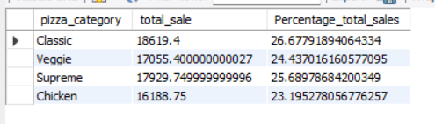

1. **Percentage of sales by pizza size**

select pizza_size, cast(sum(total_price) as decimal(10,2)) as total_sale, cast(sum(total_price) * 100 / (select sum(total_price) from pizza_sales) as decimal(10,2)) as Percentage_total_sales

from pizza_sales

group by pizza_size

order by Percentage_total_sales desc;

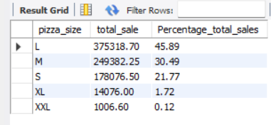

1. **Total pizzas sold by pizza category**

select pizza_category, sum(quantity) as total_pizza

from pizza_sales

group by pizza_category;

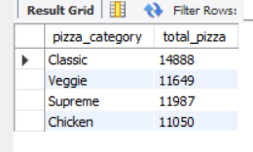

1. **Top 5 best sellers by total pizzas sold**

select pizza_name, sum(total_price) as total_revenue

from pizza_sales

group by pizza_name

order by total_revenue desc

limit 5;

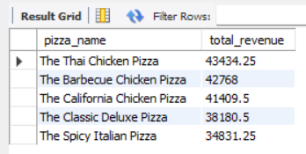

1. **Bottom 5 worst sellers by total pizzas sold**

select pizza_name, sum(total_price) as total_revenue

from pizza_sales

group by pizza_name

order by total_revenue

limit 5;

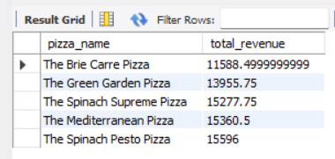

1. **Top 5 best sellers by total quantity**

select pizza_name, sum(quantity) as total_quantity

from pizza_sales

group by pizza_name

order by total_quantity desc

limit 5;

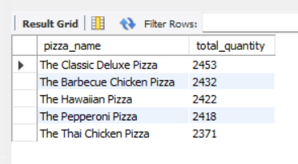

1. **Top 5 best sellers by total orders**

select pizza_name, count(distinct order_id) as total_quantity

from pizza_sales

group by pizza_name

order by total_quantity desc

limit 5;

